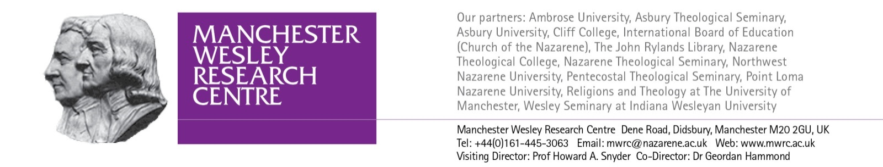
PhD Theses Published by Manchester Wesley Research Centre Junior Fellow Graduates

Wesley Studies

Joseph Basappa Suray, Towards a Theology of Universality: John Wesley's Socio-economic, Political and Moral Insights on British Class & Indian Caste Distinctions (Christian World Imprints, 2015).

Robbie Brown, Joy of Heaven to Earth Come Down: Perfection and Millennium in the Eschatology of John Wesley (Christian World Imprints, 2016).

Kiyeong Chang, Theologies of the Law in Martin Luther and John Wesley (Emeth Press, 2014).

J. Gregory Crofford, Streams of Mercy: Prevenient Grace in the Theology of John and Charles Wesley (Emeth Press, 2010).

Joseph W. Cunningham, John Wesley’s Pneumatology: Perceptible Inspiration, Ashgate Methodist Studies Series (Ashgate, 2014).

John Austin Dolan, The Independent Methodists: A History (James Clarke, 2005).

J. Russell Frazier, True Christianity: The Doctrine of Dispensations in the Thought of John William Fletcher 1729-1785 (Pickwick Publications, 2014).

Geordan Hammond, John Wesley in America: Restoring Primitive Christianity (Oxford University Press, 2014).

Mark K. Olson, ‘Exegeting Aldersgate: John Wesley’s Interpretation of 24 May 1738’. To be published in the Routledge Methodist Studies Series in 2018.

John Read, Catherine Booth: Laying the Theological Foundations of a Radical Movement (Pickwick Publications, 2013).

Stanley J. Rodes, From Faith to Faith: John Wesley’s Covenant Theology and Way of Salvation (Pickwick Publications, 2013).

David Wilson, Church and Chapel in Industrializing Society: Anglican Ministry and Methodism in Shropshire, 1760–1785 (Peter Lang, 2017).

Theology

Lord Elorm-Donkor, Christian Morality in Ghanaian Pentecostalism (Regnum, 2017).

Olga Druzhinina, The Ecclesiology of Basil the Great: A Trinitarian Approach to the Life of the Church (Pickwick Publications, 2016).

Dick Eugenio, Communion with the Triune God: The Trinitarian Soteriology of Thomas F. Torrance (Pickwick Publications, 2014).

Michael J. Gehring, The Oxbridge Evangelist: Motivations, Practices, and Legacy of C. S. Lewis (Cascade Books, 2017).

E. Jerome Van Kuiken, Christ’s Humanity in Current and Ancient Controversy: Fallen or Not? (Bloomsbury T&T Clark, 2017).

Josh McNall, “A Free Corrector”: Colin Gunton and the Legacy of Augustine (Fortress Press, 2015).

Donny Joe Payne, The Theology of the Christian Life in J I Packer’s Thought: Theological Anthropology, Theological Method and the Doctrine of Sanctification (Paternoster Press, 2006).

Carla D. Sunberg , The Cappadocian Mothers: Deification Exemplified in the Writings of Basil, Gregory and Gregory (Pickwick Publications, 2017).

Donald Leroy Stults, Grasping Truth and Reality: Leslie Newbigin’s Theology of Mission in the Western World, (James Clarke, 2009).

Biblical Studies

James Ayoodeji Adewuya, Holiness and Community in 2 Corinthians 6.14-7.1: Paul’s View of Communal Holiness in the Corinthian Correspondence (Peter Lang, 2003).

Wm Randolph Bynum, The Fourth Gospel and the Scriptures (Brill, 2012).

Rhonda Crutcher, That He Might Be Revealed: Water Imagery and the Identity of Jesus in the Gospel of John (Pickwick Publications, 2015).

Svetlana Khobnya, The Father Who Redeems and the Son Who Obeys: Consideration of Paul's Teaching in Romans (Pickwick Publications, 2013).

Musa Victor Mdabuleni Kunene, Communal Holiness in the Gospel of John, The Vine Metaphor as a Test Case with Lessons from African Hospitality and Trinitarian Theology (Langham Partnership International, 2012).

Mart Alan Michelson, Reconciling Violence and Kingship: A Study of Judges and 1 Samuel, (Pickwick Publications, 2011).

Robert S. Snow, Daniel’s Son of Man in Mark: A Redefinition of the Jerusalem Temple and the Formation of a New Covenant Community (Pickwick Publications, 2016).

Mary Beth Spaulding, Commemorative Identities: Jewish Social Memory and the Johannine Feast of Booths (T&T Clark, 2009).

Sarah Whittle, Covenant Renewal and the Consecration of the Gentiles in Romans, Society for New Testament Studies Monograph Series 161 (Cambridge University Press, 2014).

Updated April 2017

